Big Data Analysis with IBM Cloud Databases – CAD101

# ABSTRACT :

This comprehensive guide outlines the process of conducting Big Data analysis using IBM Cloud databases, with a primary focus on leveraging IBM Db2 on Cloud—a robust cloud-based database solution.

The steps encompass setting up an IBM Db2 instance, ingesting and preparing data for analysis, utilizing SQL and analytics functions for data exploration, integrating advanced analytics and machine learning, optimizing performance, ensuring security and compliance, and visualizing insights. The aim is to empower businesses to efficiently analyze large and complex datasets, derive valuable insights, and make data-driven decisions using IBM Cloud's powerful database services.

# OBJECTIVES :

1. **Efficient Data Ingestion and Storage:**
   * Streamline the process of ingesting and storing large and varied datasets within IBM Db2 on Cloud for effective data management and analysis.

# Data Preparation and Quality Assurance:

* + Ensure data is cleansed, transformed, and prepared in a structured format suitable for analysis, while maintaining data quality and accuracy.

# Advanced Data Analysis and Exploration:

* + Leverage SQL queries, analytics functions, and advanced analytical capabilities of IBM Db2 on Cloud to perform in- depth data analysis, exploratory data analysis (EDA), and uncover meaningful insights.

# DESIGN THINKING :

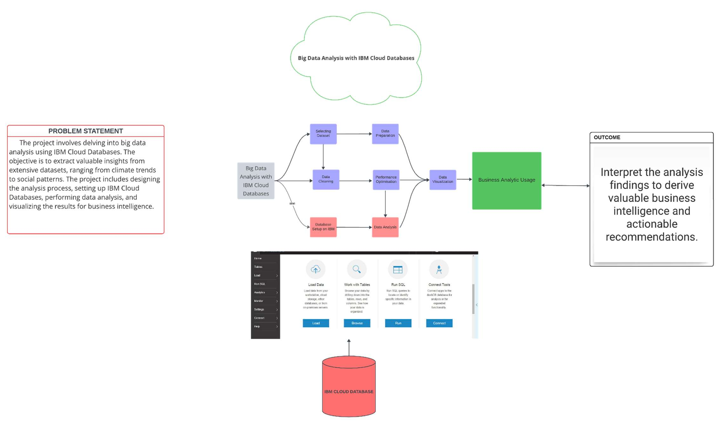

**WORKFLOW :**

1. Ingest data into IBM Db2 on Cloud.
2. Preprocess and clean the data within Db2 to ensure data quality
3. Perform exploratory data analysis and analytics using Db2's SQL capabilities.
4. Integrate machine learning models for predictive analytics.
5. Visualize insights and generate reports using visualization tools
6. Optimize performance and ensure scalability for efficient data analysis.
7. Implement security measures and ensure compliance with regulations.
8. Continuously monitor and maintain the Db2 instance for optimal performance.

# PROCESS :

* 1. Setup an IBM Db2 on Cloud Instance:
     + Log in to IBM Cloud account and create an instance of IBM Db2 on https://[www.ibm.com/cloud/free/databases](http://www.ibm.com/cloud/free/databases)
     + Choose the appropriate plan and configure the instance according to needs, considering factors such as storage, compute, and geographic location.
  2. Ingest Data into Db2:
     + Import big data into the IBM Db2 on Cloud database. This could involve loading data from various sources such as files, existing databases, or streaming data.
  3. Data Preparation and Cleaning:
     + Clean and preprocess the data within Db2 to ensure it's in a suitable format for analysis. This step may include handling missing values, data transformations, and normalization.
  4. Data Analysis using SQL and Analytics Functions:
     + Utilize SQL queries and analytics functions supported by Db2 to analyze the data. Perform exploratory data analysis (EDA), aggregation, statistical analysis, and other relevant operations to gain insights into the dataset.
  5. Leverage Advanced Analytics and Machine Learning:
     + Utilize Db2's advanced analytics capabilities, including machine learning models, to perform predictive analysis, clustering, classification, or regression on the data.
  6. Data Visualization and Reporting:
     + Use visualization tools such as IBM Cognos Analytics, Tableau, or IBM Watson Analytics to create visualizations

and reports based on the analyzed data. Visualization helps in presenting insights in an easily understandable format.

# Innovation in Big Data Analysis with IBM Cloud Databases – CAD101

1. **Data Integration and Management:**

Data Integration: Utilize Db2's data integration capabilities to combine structured and unstructured climate data from various sources, including satellite imagery, weather stations, and climate models. Db2 can handle diverse data formats and integrate them seamlessly.

Data Cleaning and Transformation: Use Db2's data cleaning tools to handle missing or inconsistent data. Clean, transform, and prepare the data for analysis, ensuring data accuracy and consistency.

1. **Scalable Data Storage:**

Scalability: Db2 oﬀers scalability to handle large volumes of climate data efficiently. Store historical, real-time, and forecast data in Db2, ensuring fast and reliable data retrieval for analysis.

Data Partitioning: Implement data partitioning strategies in Db2 to distribute large datasets across multiple storage devices, optimizing query performance for climate impact predictions.

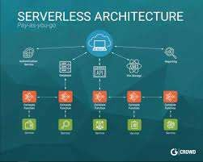

1. **Advanced Analytics with Db2:**

Machine Learning Integration: Utilize Db2's machine learning capabilities to build predictive models for climate impact predictions. Train machine learning algorithms using historical climate data stored in Db2, allowing the system to learn patterns and make accurate predictions.

In-Database Analytics: Perform advanced analytics directly within Db2, reducing data movement and improving processing speed. Run complex algorithms within the database, leveraging Db2's processing power for climate-related calculations.

1. **Real-time Data Processing:**

Streaming Data Processing: Integrate Db2 with streaming data sources to process real-time climate data. Analyze streaming data to detect patterns, anomalies, or extreme weather events as they happen, enabling timely responses and predictions.

1. **Spatial and Temporal Analysis:**

Spatial Data Processing: Use Db2's spatial extensions to analyze geographical data. Perform spatial analysis to understand the impact of climate change on specific regions, ecosystems, or urban areas.

1. **Temporal Data Analysis:** Db2 supports temporal data, allowing you to analyze climate data across different time periods. Perform trend analysis and forecast future climate scenarios based on temporal patterns stored in Db2.
2. **Data Visualization and Reporting:**

Integration with Visualization Tools: Integrate Db2 with data visualization tools like IBM Cognos or Tableau. Create interactive dashboards and visualizations to communicate climate impact predictions effectively to stakeholders.

Automated Reporting: Set up automated reporting in Db2 to generate regular climate impact reports. Schedule reports to be generated at specific intervals, providing stakeholders with up-to-date insights into climate predictions and trends.

# DEVELOPMENT

**Introduction :**

**In this phase we are going to get the data and to load the data of climate change in different countries and different cities , by using the IBM Db2 service instance, and also to explore the data average temperature in global by running the SQL queries.**

**Requirements :**

**Ibm Cloud , Dataset**

1. **GO TO CLOUD**

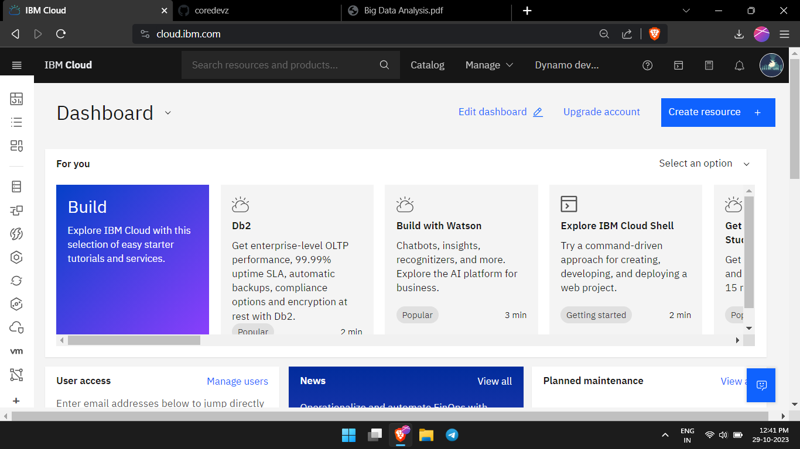

1. **CREATE DB 2 INSTANCE**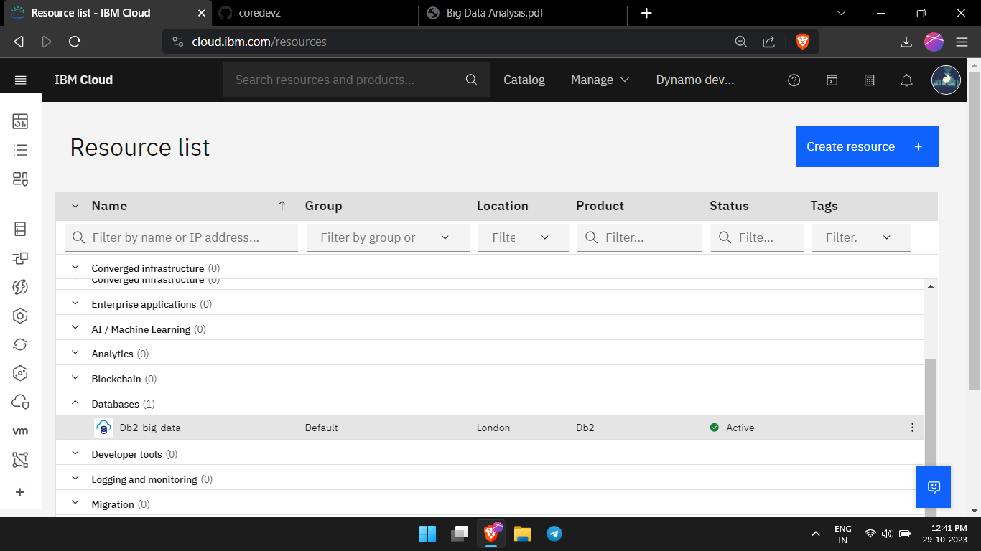
2. **IMPORT THE CSV FILE**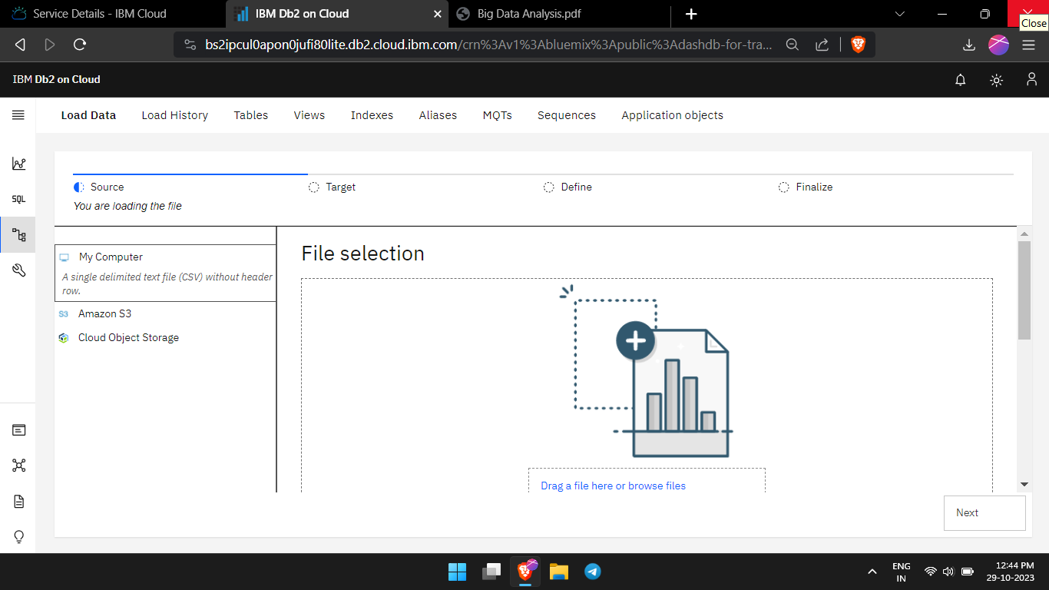
3. **DOWNLOAD THE DATASET**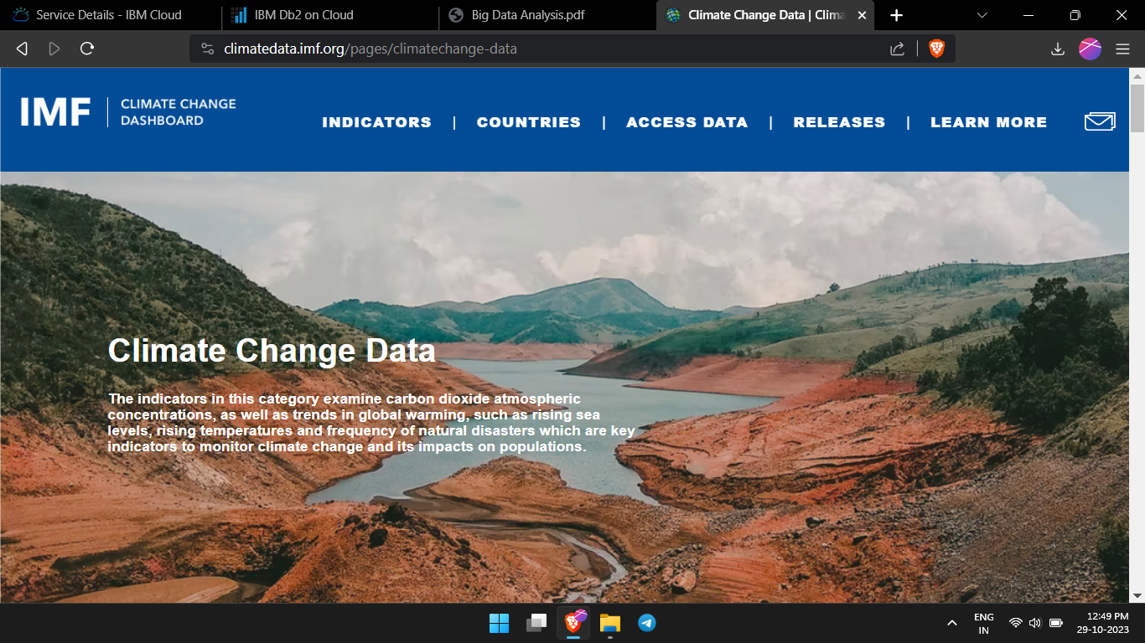
4. **CREATE A SPACE**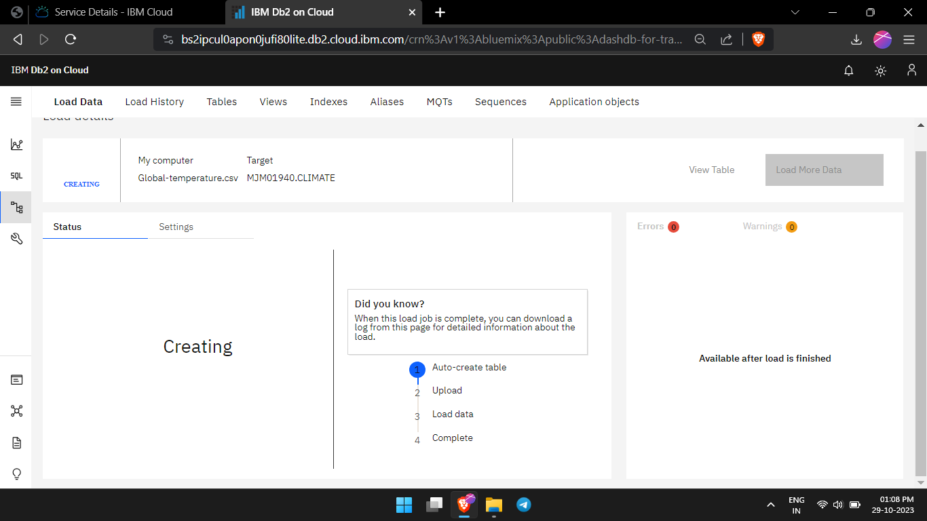
5. **LOAD THE JOB**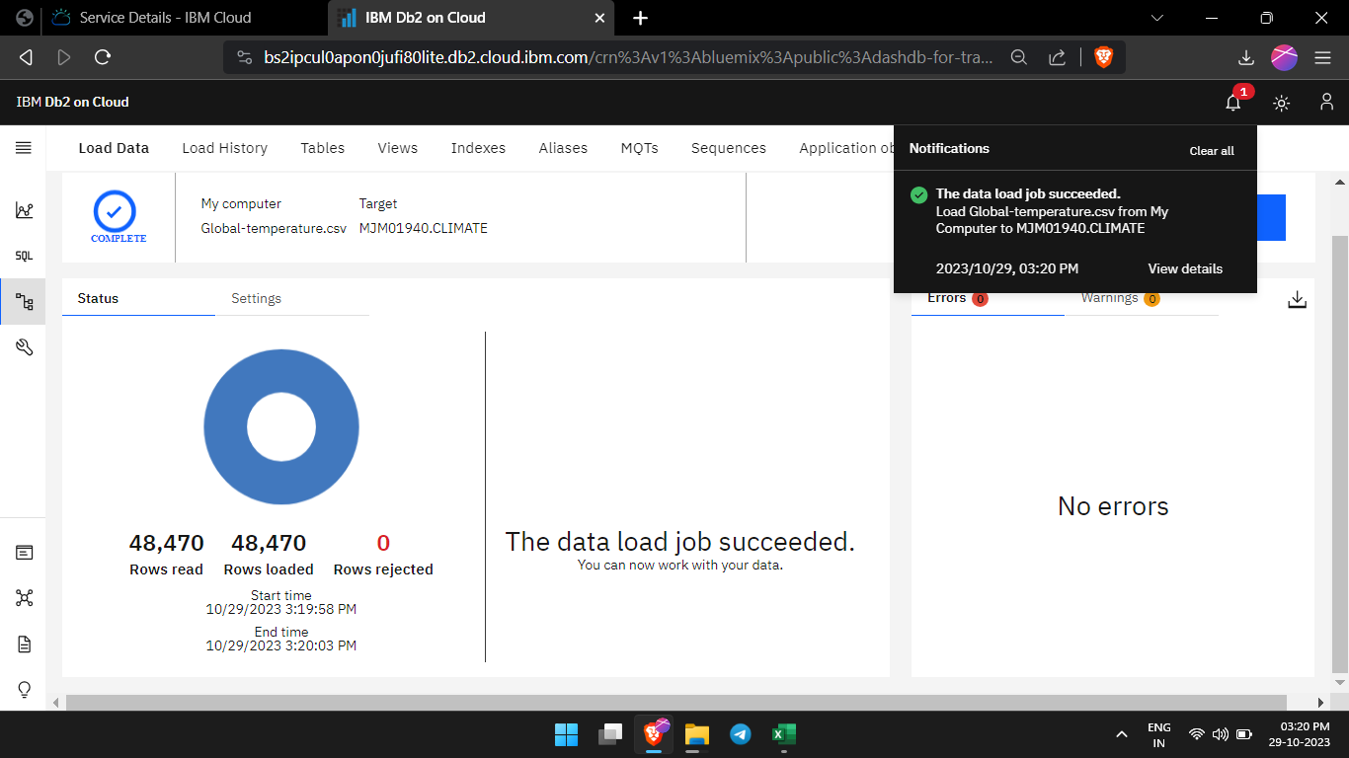
6. **DISPLAY THE DATA**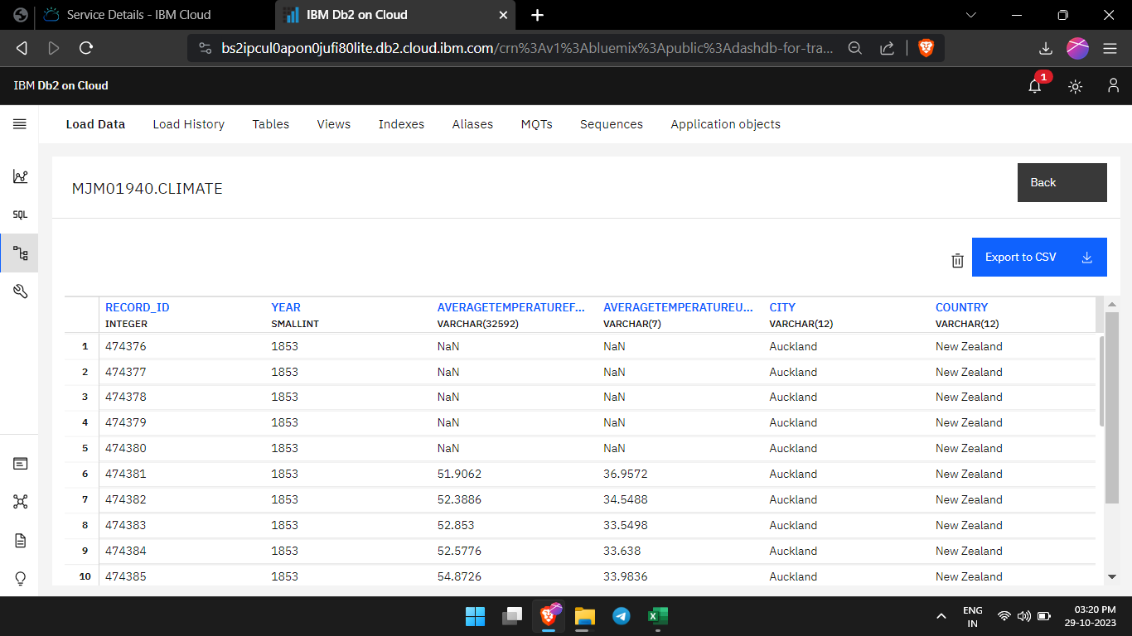
7. **RUN THE SQL SCRIPT**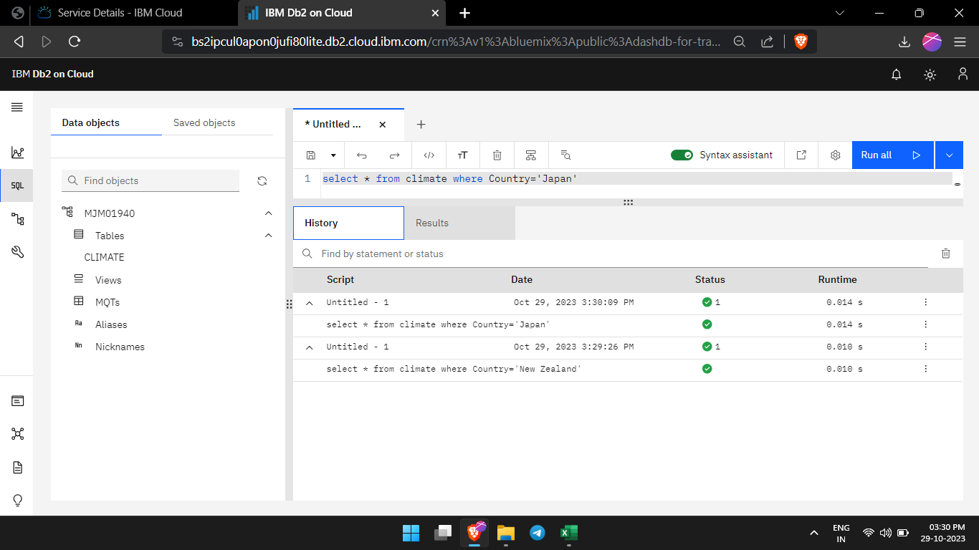
8. **GET THE OITPUT**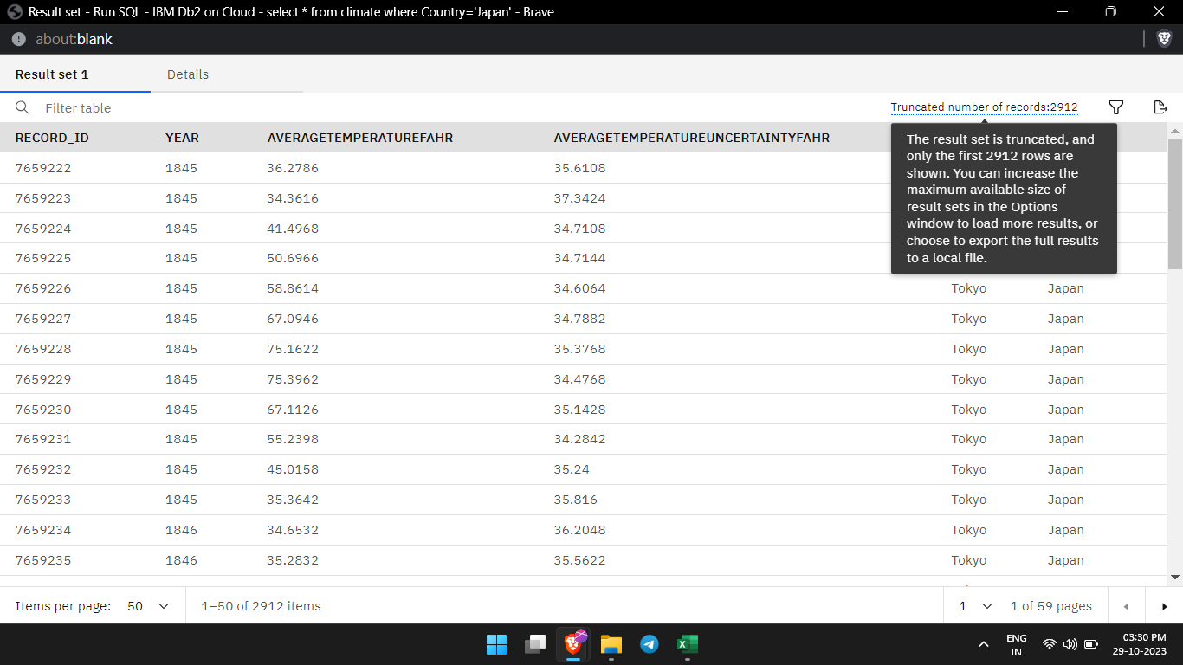
9. **RUN VARIOUS QUERY FOR DATA**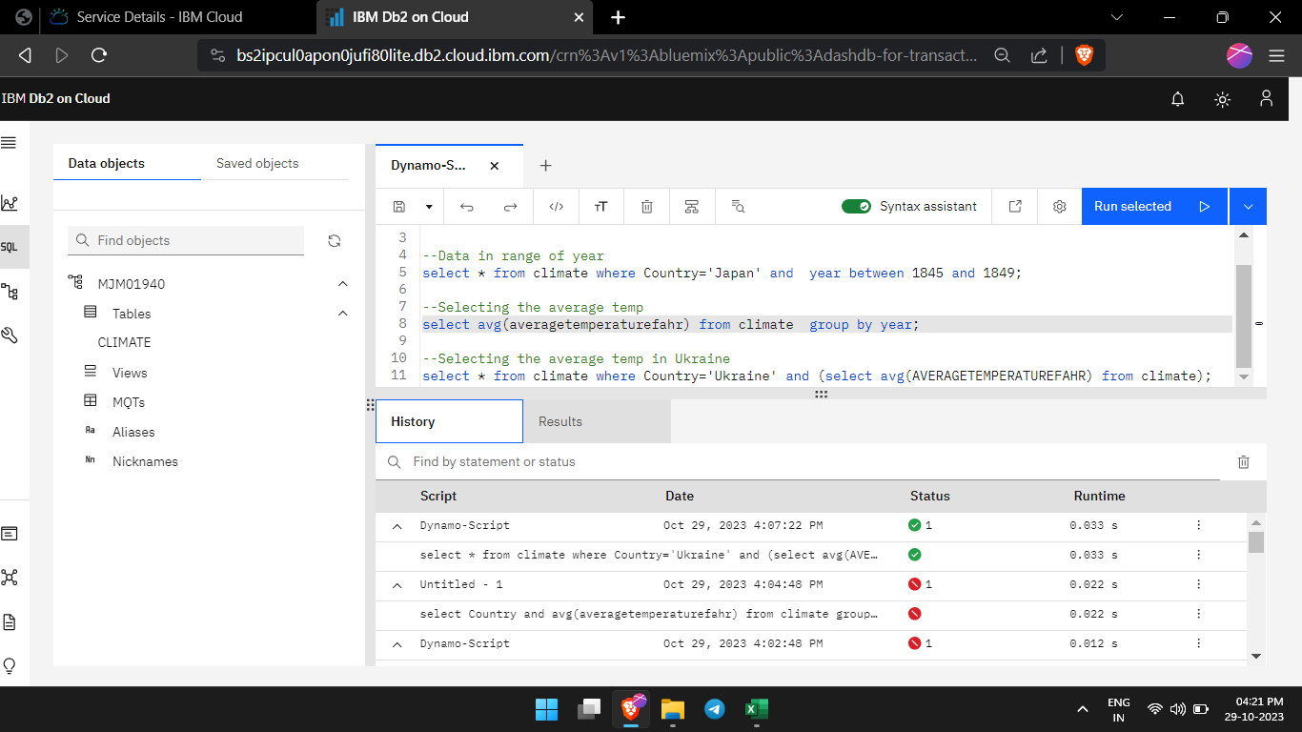
10. **ANALYSE THE RESULTS**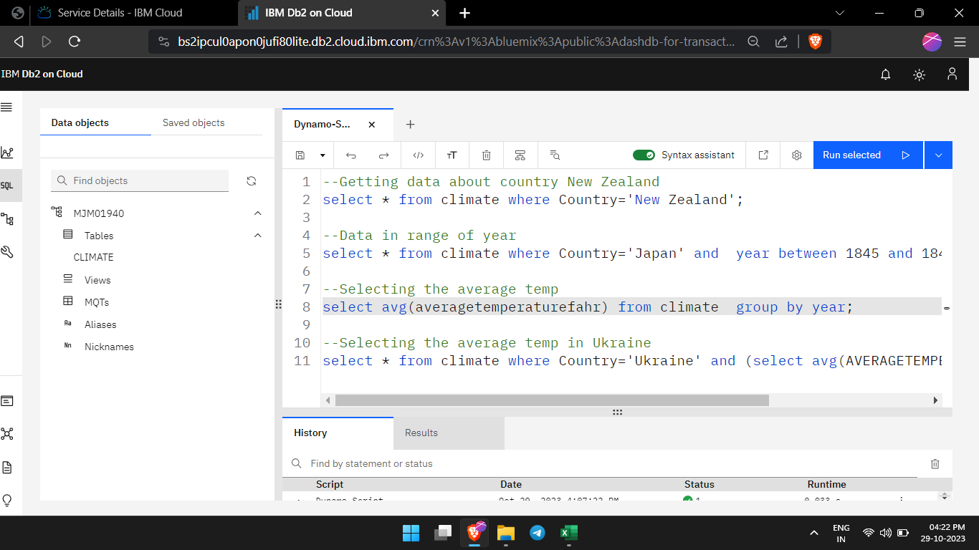
11. **GET THE DATA**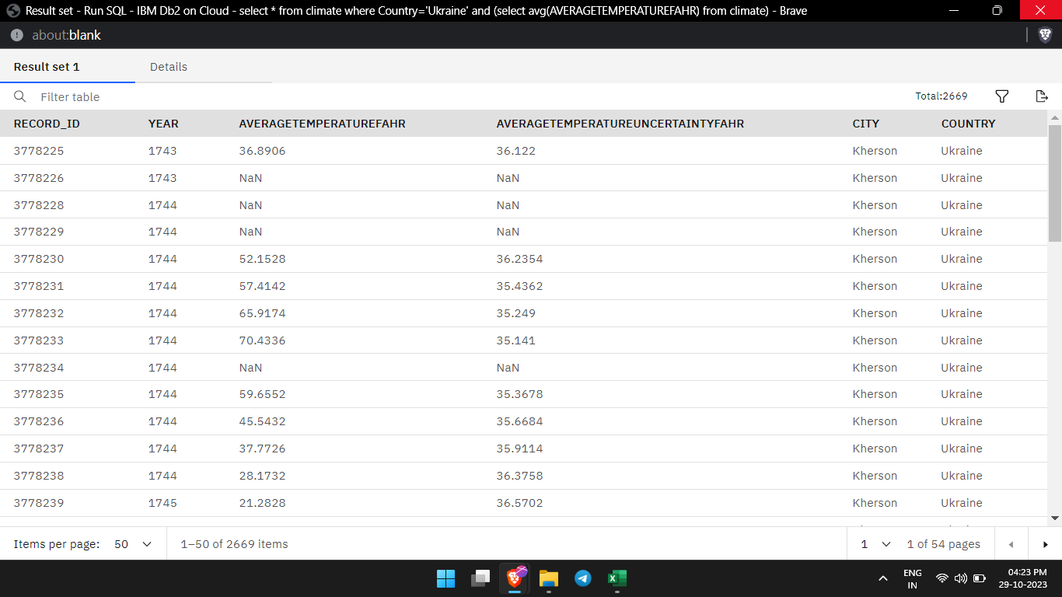

**In this Step we are going to get the data and to advanced analysis techniques and visualizing the results by NLTK Natural Language Toolkit.**

**We will do it by following steps Ahead!**

**Requirements:**

**Ibm Db2,Dataset,Watson Studio, Model to predict**

1. **GO TO Watson Studio Data Pak**

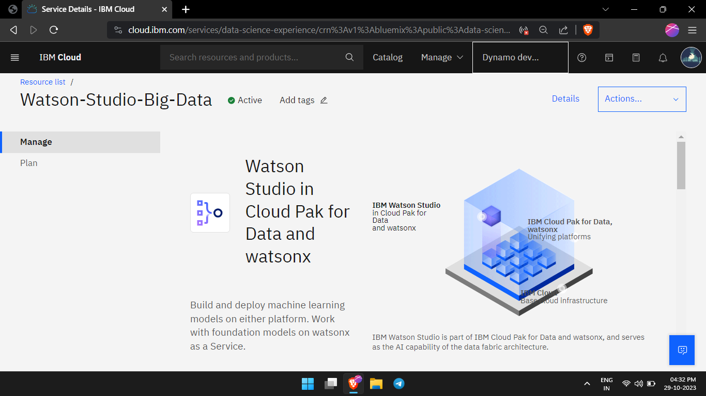

1. **CREATE AN INSTANCE**

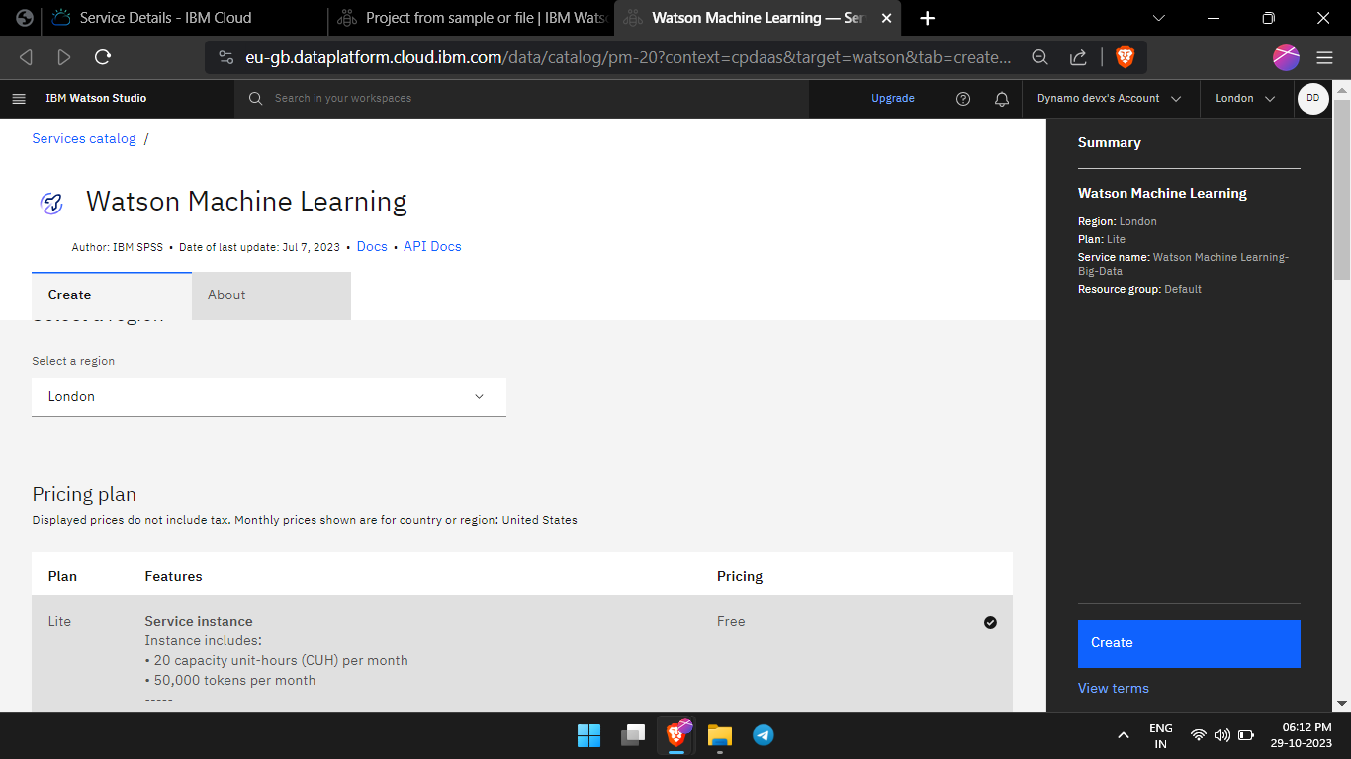

1. **CREATE A CLIMATE PROJECT**

1. **NAVIGATE TO DASHBOARD**

1. **INITIALISE THE vCPU CLOUD MACHINE**

1. **UPLOAD THE DATASET , PMML MODEL , VISULISATION PROGRAM**

1. **GET THE ACCESS KEYS / GENERATE THE PROJECT Token Key / ID and Specify the Urls**

1. **GET THE PREDICTION FOR FORECASTING WEATHER**A screen shot of a computer program

   Description automatically generated

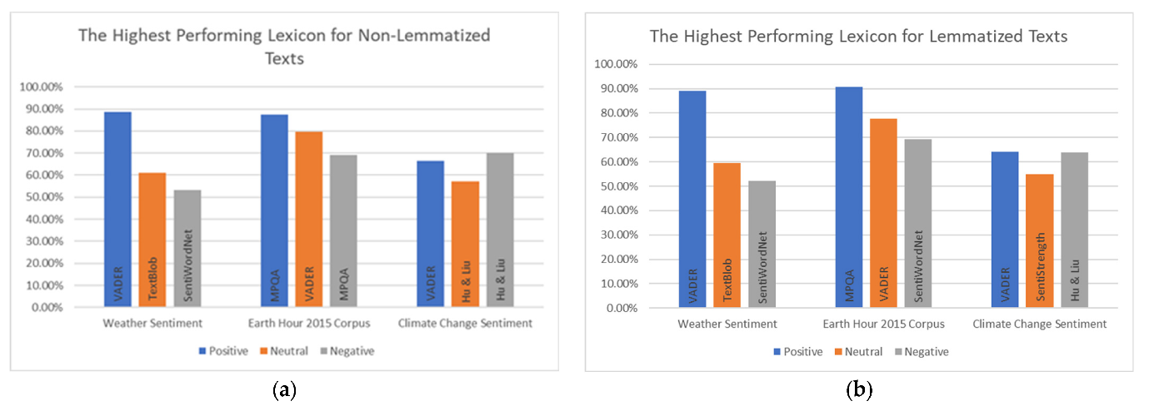

1. **START RUNNING THE CELLS IN JUPYTER-NOTEBOOK**A screenshot of a computer

   Description automatically generated
2. **BY USING THE PANDAS in Python Plot the analysis for visualization**

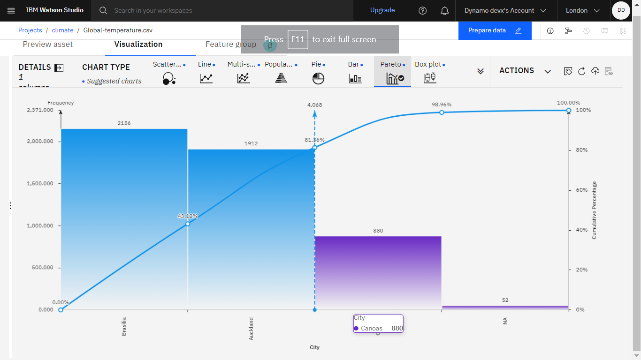

**How the analysis findings translate into valuable business insights?**

1. **Data Collection and Preparation:**
   * **Start by collecting and organizing relevant data from various sources, which may include customer data, sales records, market research, or any other pertinent information. This data needs to be cleaned and prepared to ensure accuracy and consistency.**
2. **Data Analysis:**
   * **The statistical analysis, data mining, machine learning, or data visualization, to examine the data. These methods help identify patterns, trends, correlations, and anomalies in the data.**
3. **Interpretation of Findings:**
   * **Analyze the results of the data analysis to understand what the data is telling you. This step requires domain expertise to interpret the findings within the context of your business.**
4. **Insights Generation:**
   * **Insights should provide valuable information about customer behavior, market dynamics, operational efficiency, and more.**
5. **Prioritization of Insights:**
   * **Not all insights are equally valuable or actionable. Prioritize insights based on their potential impact on the organization's objectives and APIs. Focus on those that have the most significant relevance and potential for improvement.**
6. **Contextualization:**
   * **Place the insights within the broader context of your business environment and industry. Understand how these insights fit into your competitive landscape and market dynamics.**
7. **Validation and Testing:**
   * **Verify the accuracy and reliability of the insights through testing and validation. This may involve conducting experiments or A/B testing to confirm that the recommended actions yield the expected results.**
8. **Actionable Recommendations:**
   * **Translate the insights into clear, actionable recommendations for the organization. These recommendations should be practical, specific, and linked to measurable outcomes. They can relate to marketing strategies, product development, cost reduction, customer service, and more.**
9. **Resource Allocation:**
   * **Determine the resources required to implement the recommendations, including budget, personnel, and technology.**
10. **Change Implementation:**
    * **Execute the recommended changes in your business operations or strategies. This could involve modifying marketing campaigns, altering product features, optimizing supply chain processes, or making other operational adjustments.**

**CONCLUSION :**

**In this solution, we successfully conducted big data analysis using IBM Cloud Databases. By following the problem definition, design thinking, development, and documentation phases, we designed and implemented an analysis process that extracts insights from vast datasets.**

**The solution utilized IBM Cloud Databases to store and manage the data, applied advanced analysis techniques, and visualized the results for valuable business intelligence. Through data-driven adventures, we explored the endless possibilities of big data and uncovered hidden insights in climate trends or social patterns**